Name……………………… Date:…………………

Year 7 Classification Cracking the classification code
Each level of the Linnaean classification system is like a code that describes the way an organism looks or behaves.

Kingdom – broken up into 5 groups (today we are mixing Monera and Protista into one group)
Animalia – has many cells with a nucleus, is able to move freely from one area to another, needs to eat nutrients and gives birth to live young.
Plantae – has many cells with a nucleus and cell wall. Although it can move one part of its body, it usually stays in the one place. It uses photosynthesis to makes its own food (it has green chlorophyll) and has seeds.
Fungi – usually has many cells with cell walls, needs to eat its nutrients, has spores instead of seeds and usually does not move from place to place.
Monera/Protista – monera – single cell, Protista single or more cells. Has cell walls. Examples bacteria, ameobas, plankton, seaweed

Follow these instructions to identify the kingdoms the pictures belong to. Fill in the names on the table on the next page.

- Separate the green plants. These are the plantae group.

- Separate the animals. These are animalia group.

- Separate the mushrooms. These are the fungi.

- The remainder will fall into Monera or Protista.

- Record which Kingdom each picture falls into.

- Try to label the common name for the animalia and plantae.

Table 1.0 Kingdom Classification

Picture | Kingdom | Common Name
a
b
c
d
e
f
g
h
i
j
k
l
m
n
o
p
q
r
s
t
u
v
w
x
y
z
aa
bb

- 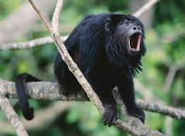 e. 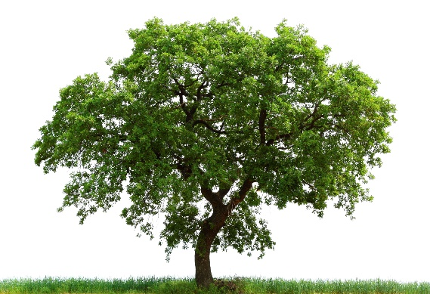
- 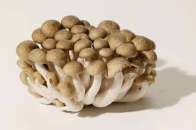 f. 

- 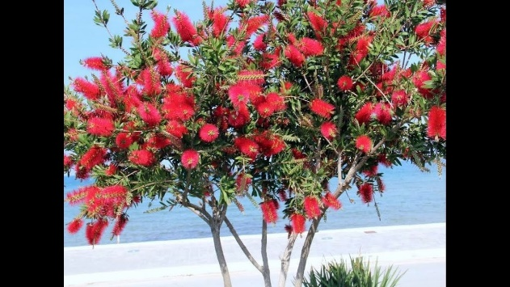 g. 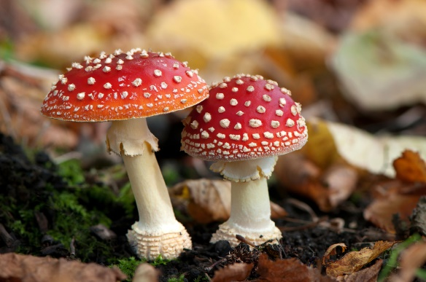
- 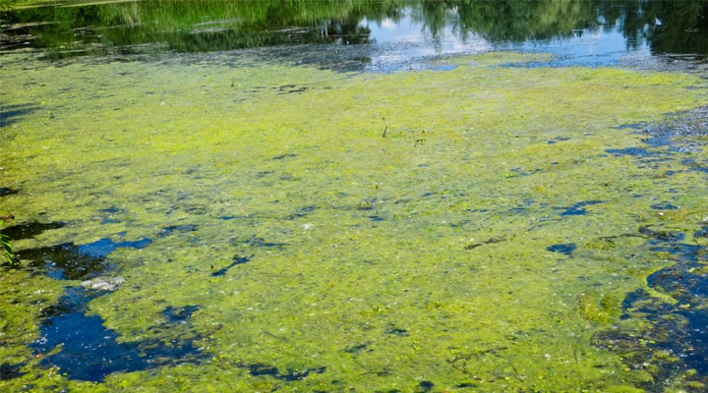 h. 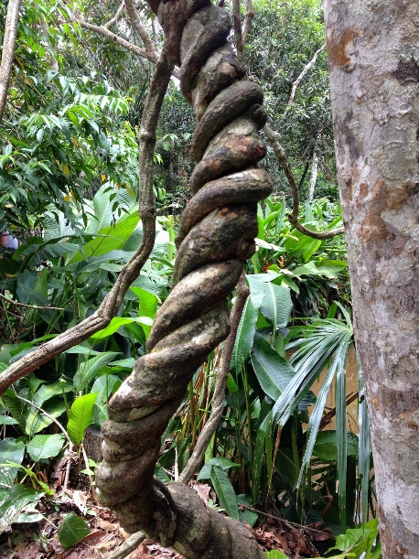

- 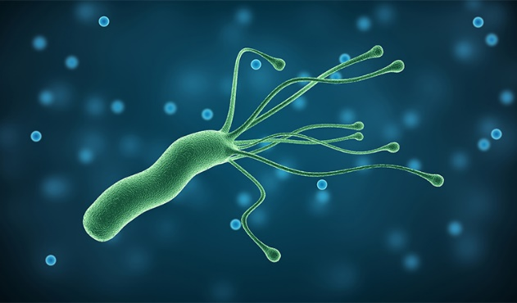 m. 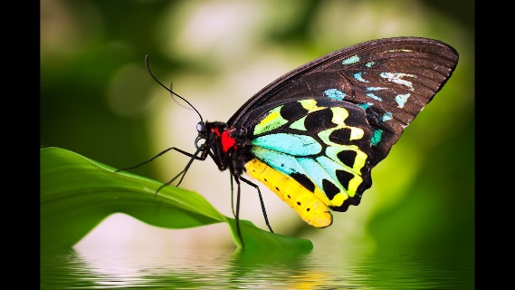

- 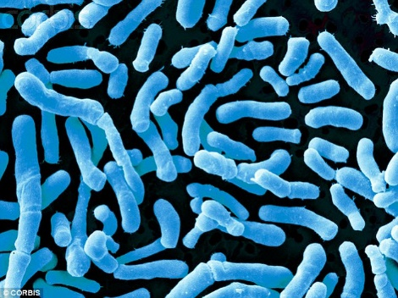 n. 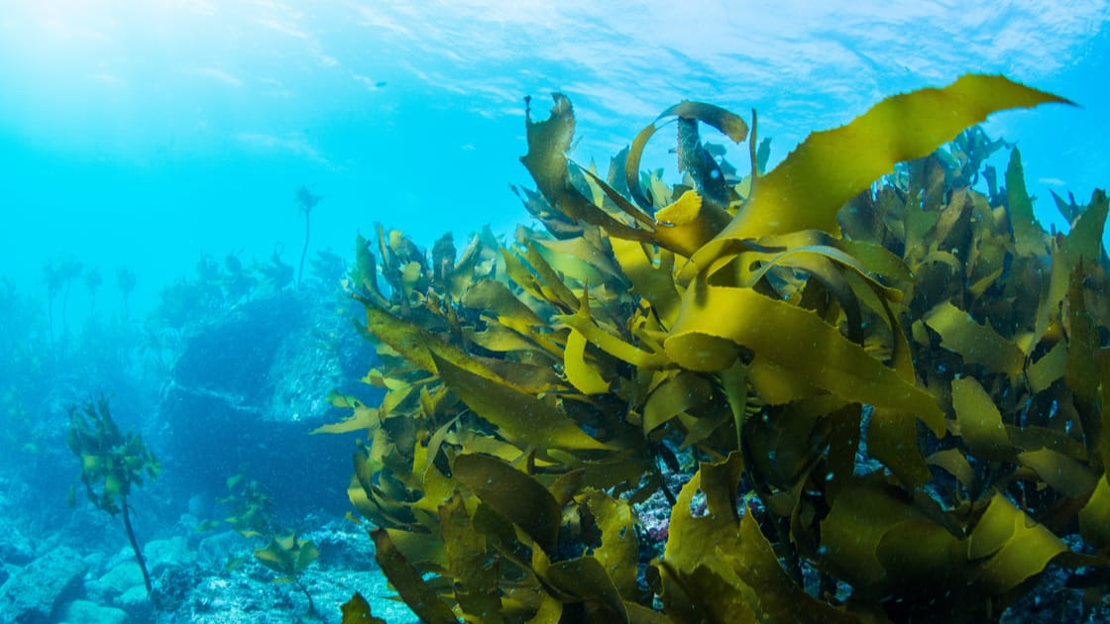

- 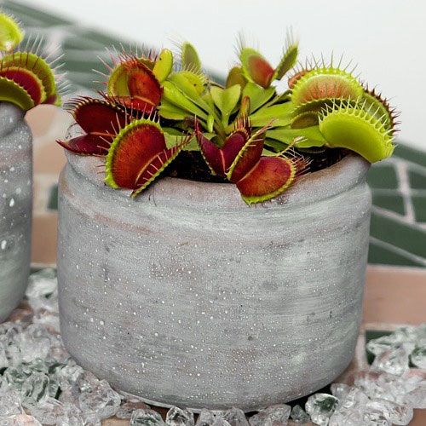 o. 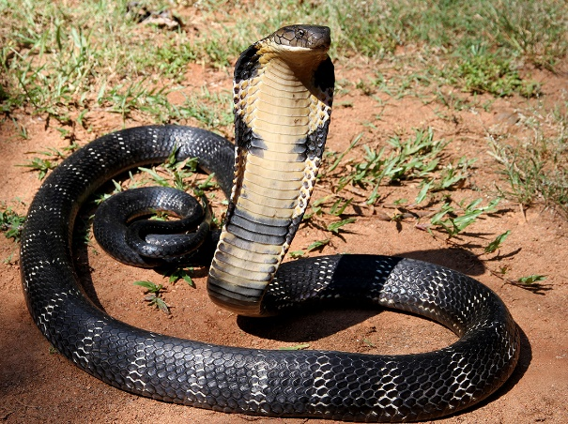
- 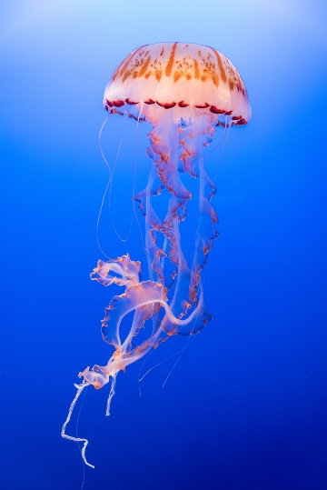 p. 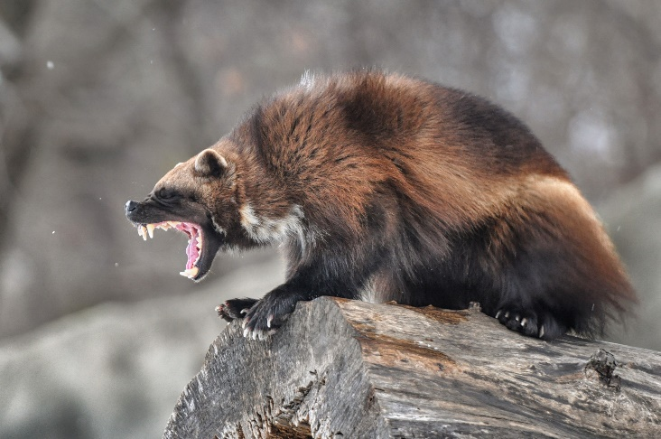

q. 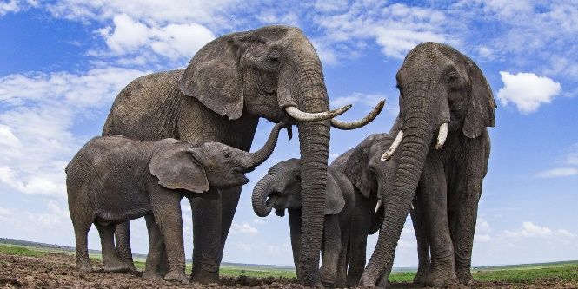 u. 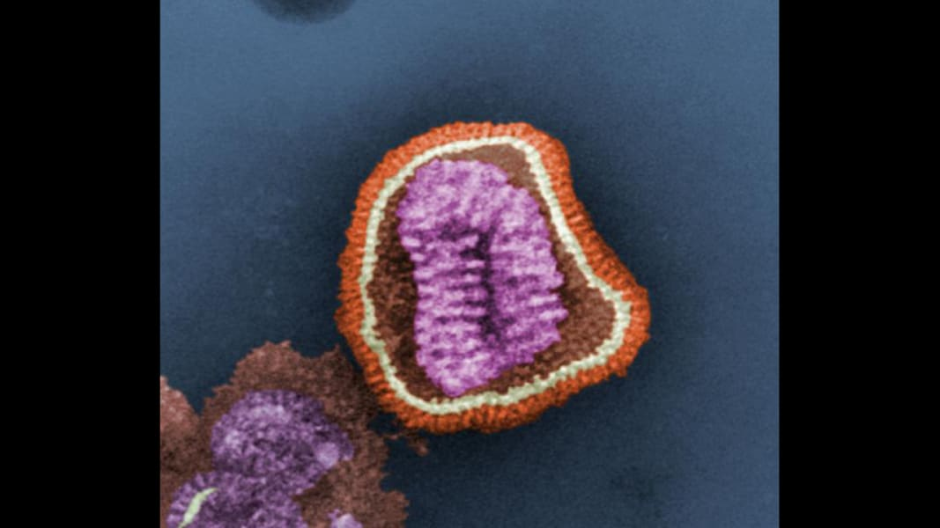
r. 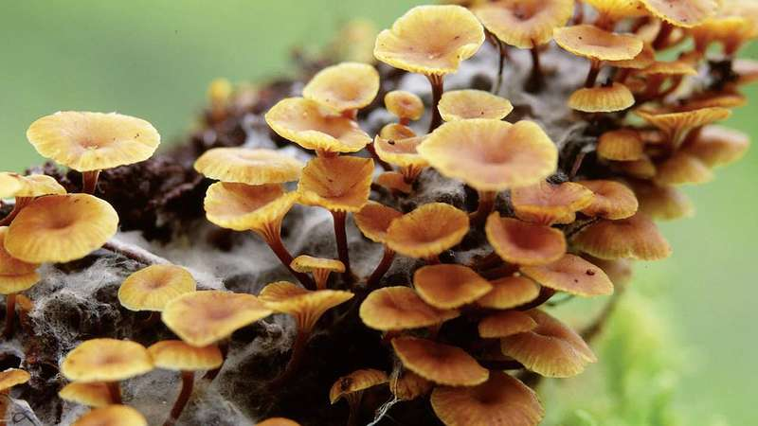 v. 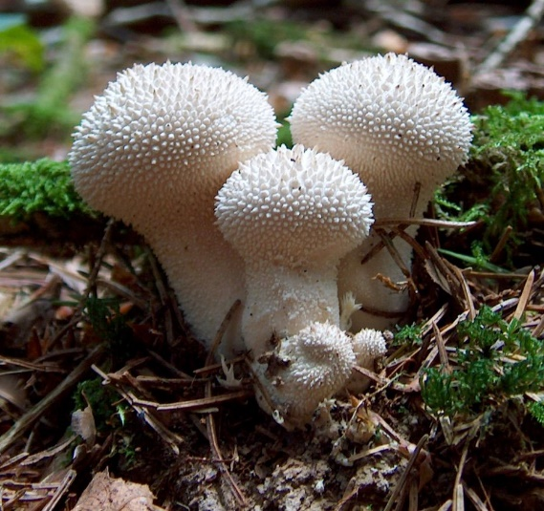
s. 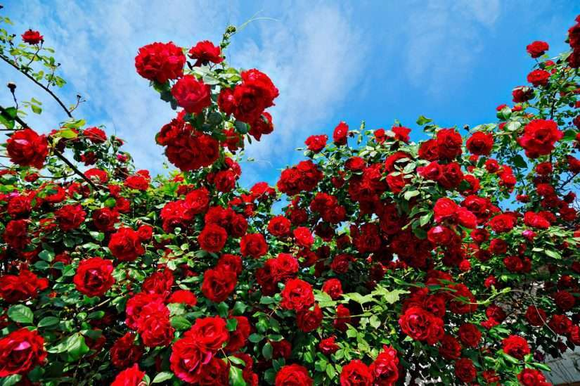 w. 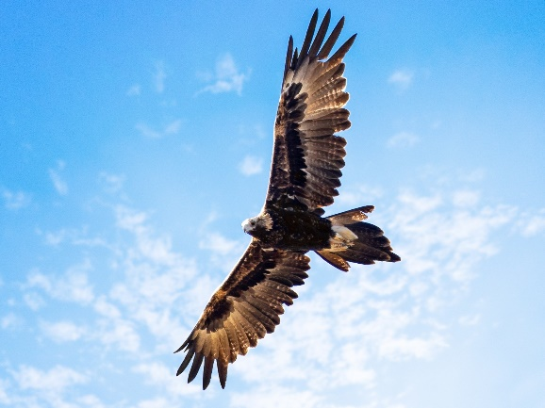
t. 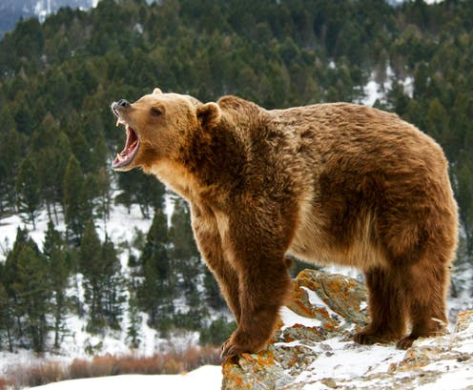 x. 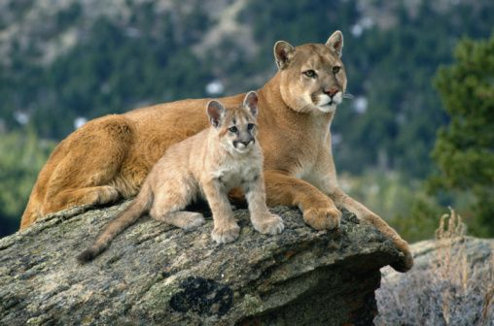

y. 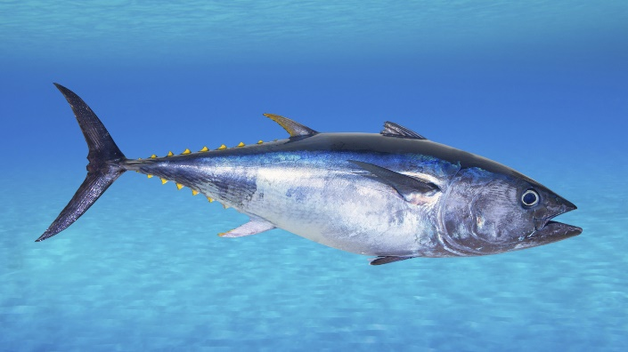

z. 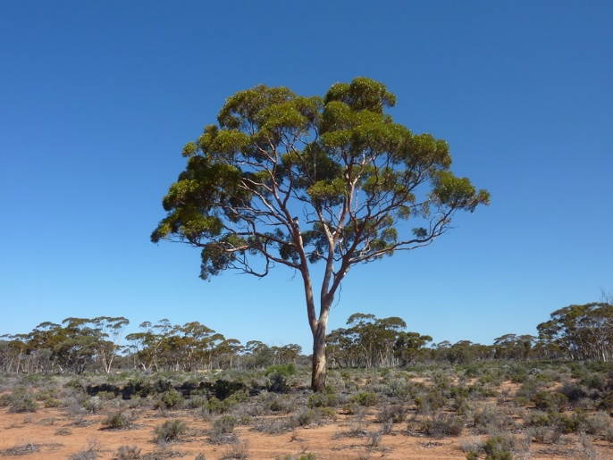

aa. 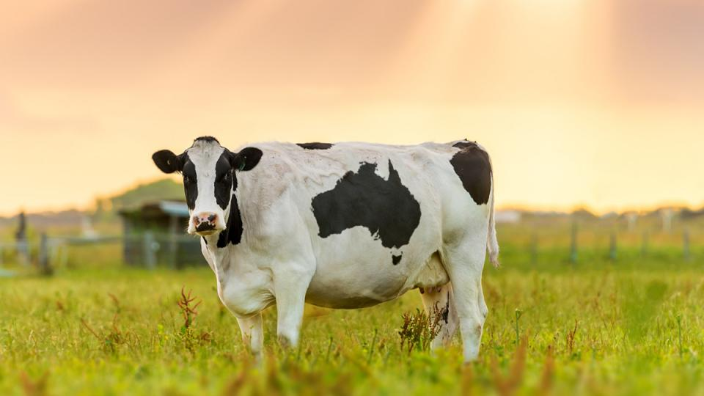

bb. 

